Western India Slam, Indore
26-31 JULY 2025
Under aegis of Rajasthan Squash Rackets Association and Squash Rackets Federation Of India
ASF Silver event, 5 Star National Circuit Tournament
Important Info | Player Guidelines - http://indiasquash.com/pdf/Player%20Guide%20-Ver%201.0.pdf
Important Info | Championship Guidelines - http://www.indiasquash.com/pdf/Ranking%20Guidelines%202018.pdf
Registration Open Date – 01st JUNE 2025  Registration Closing Date – 18th JUNE 2025 |  | Juniors – 5 star | Seniors |  |  | Masters
Local players entry fee - INR 1000  Foreign players entry fee – INR 2500 |  | Prize money - No Prize money for Juniors. Senior PSA Satellite Men & Women |  | Play offs - Top 8 for Juniors  Format – Knockout
Seeding based on – APRIL 2025 |  | Draw Type – Qualification & Main Draw (Top 8 is directly selected into main draw)  Qualification Matches Starts on 26TH JULY &  Main Draw Matches Starts on 28TH JULY.  At the conclusion of the qualification event, successful qualifiers will be drawn into main draw through the Chit picking.  Chit Picking will happen soon in the championship office soon after the matches are over in the respective age groups on the final day of the Qualification.
Events - Boys and Girls - 11, 13, 15, 17 and U19
PSA SATELLITE ($1000 Men and $1000 Women)

Championship Venue - DALY COLLEGE, 1 RESIDENCY AREA, INDORE, MADHYA PRADESH 452001
Court Type  5 AC Squash Courts |  | Air-conditioned – Yes (5 Courts) |  |  | Tin Height – 17 & 19 inches
Organising Chairman - Dr. Gunmeet Bindra |  | Phone - |  |  | Email ID – gajusquash@gmail.com
Championship Director – Mr. Gajendra Singh |  | Phone - 9827257549 |  |  | Email ID – gajusquash@gmail.com
Championship Administrator: Mr. Suresh Aravind |  | Phone - +91 8148807517 |  |  | Email ID –  suresharavind@indiasquash.com
Federation Contact | National Circuit Chairman - Cyrus Poncha | cponcha@gmail.com | Grievance - office@indiasquash.com
Functions | Prize Distribution ceremony will be on 31st JULY. It is mandatory for all medal winners to be present at the prize distribution ceremony. Awards will not be given to any other person.
Prize money deductions | TBC
Disclaimer | The SRFI will not be responsible or liability for the welfare or safety of players / officials during the Championship, Whilst the organising body will take all reasonable steps to advise players / officials on this matter, it remains the responsibility of players to confirm their own appropriate insurance cover and for the organiser of the event to ensure full and adequate safety, security and insurance measures being in place for players / officials.
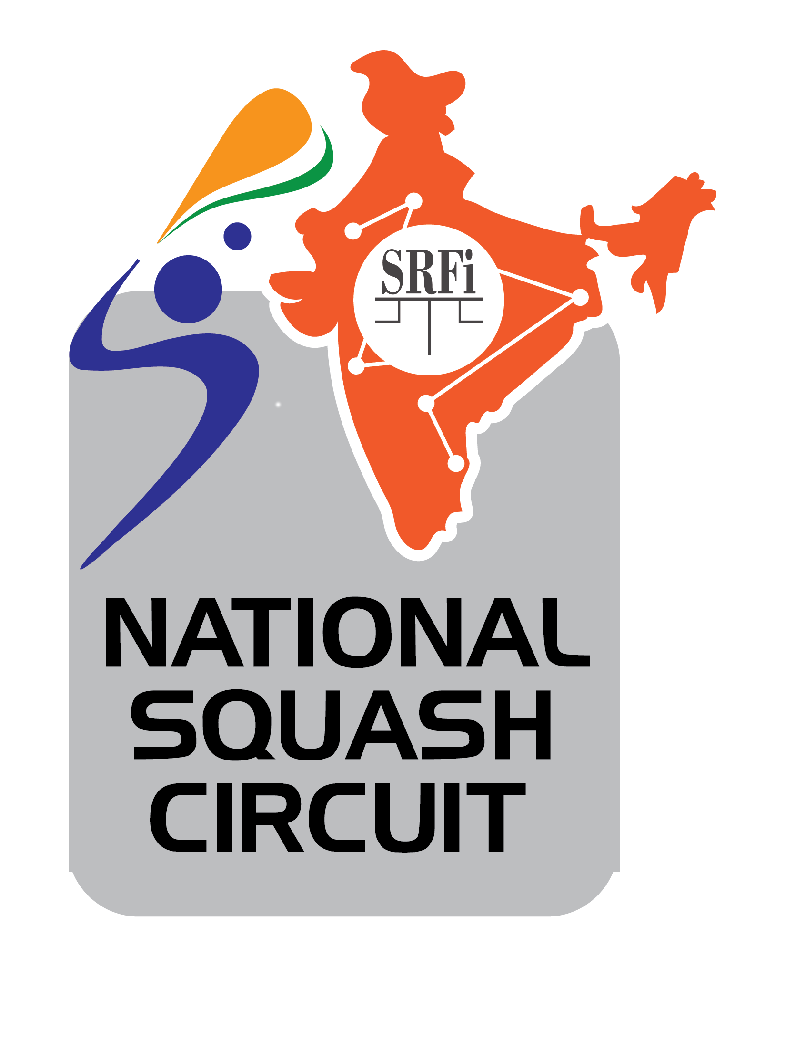


Championship Hotels
Wow Crest, Indore
Address Plot No. 106 Scheme No. 54 PU - 3 Commercial, AB Rd, Indore, Madhya Pradesh 452010
Superior & Deluxe
Single Occupancy - Rs. 5000 (complimentary breakfast)
Double Occupancy – Rs 5500 (complimentary breakfast)
Executive
Single Occupancy - Rs. 7500 (complimentary breakfast)
Double Occupancy – Rs 8000 (complimentary breakfast)
Premium Suite
Single Occupancy - Rs. 12500 (complimentary breakfast)
Double Occupancy – Rs 13000 (complimentary breakfast)
For Reservations
Contact – Trupen Patel / Phone number - +91 9769850980 / +91 73167111111
Hotel email – trupen.patel@tajhotels.com

